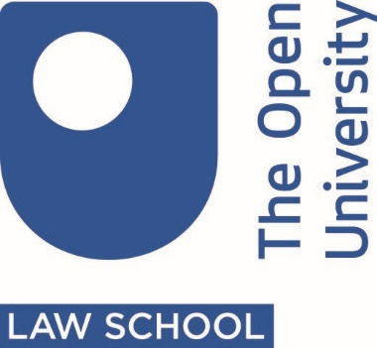
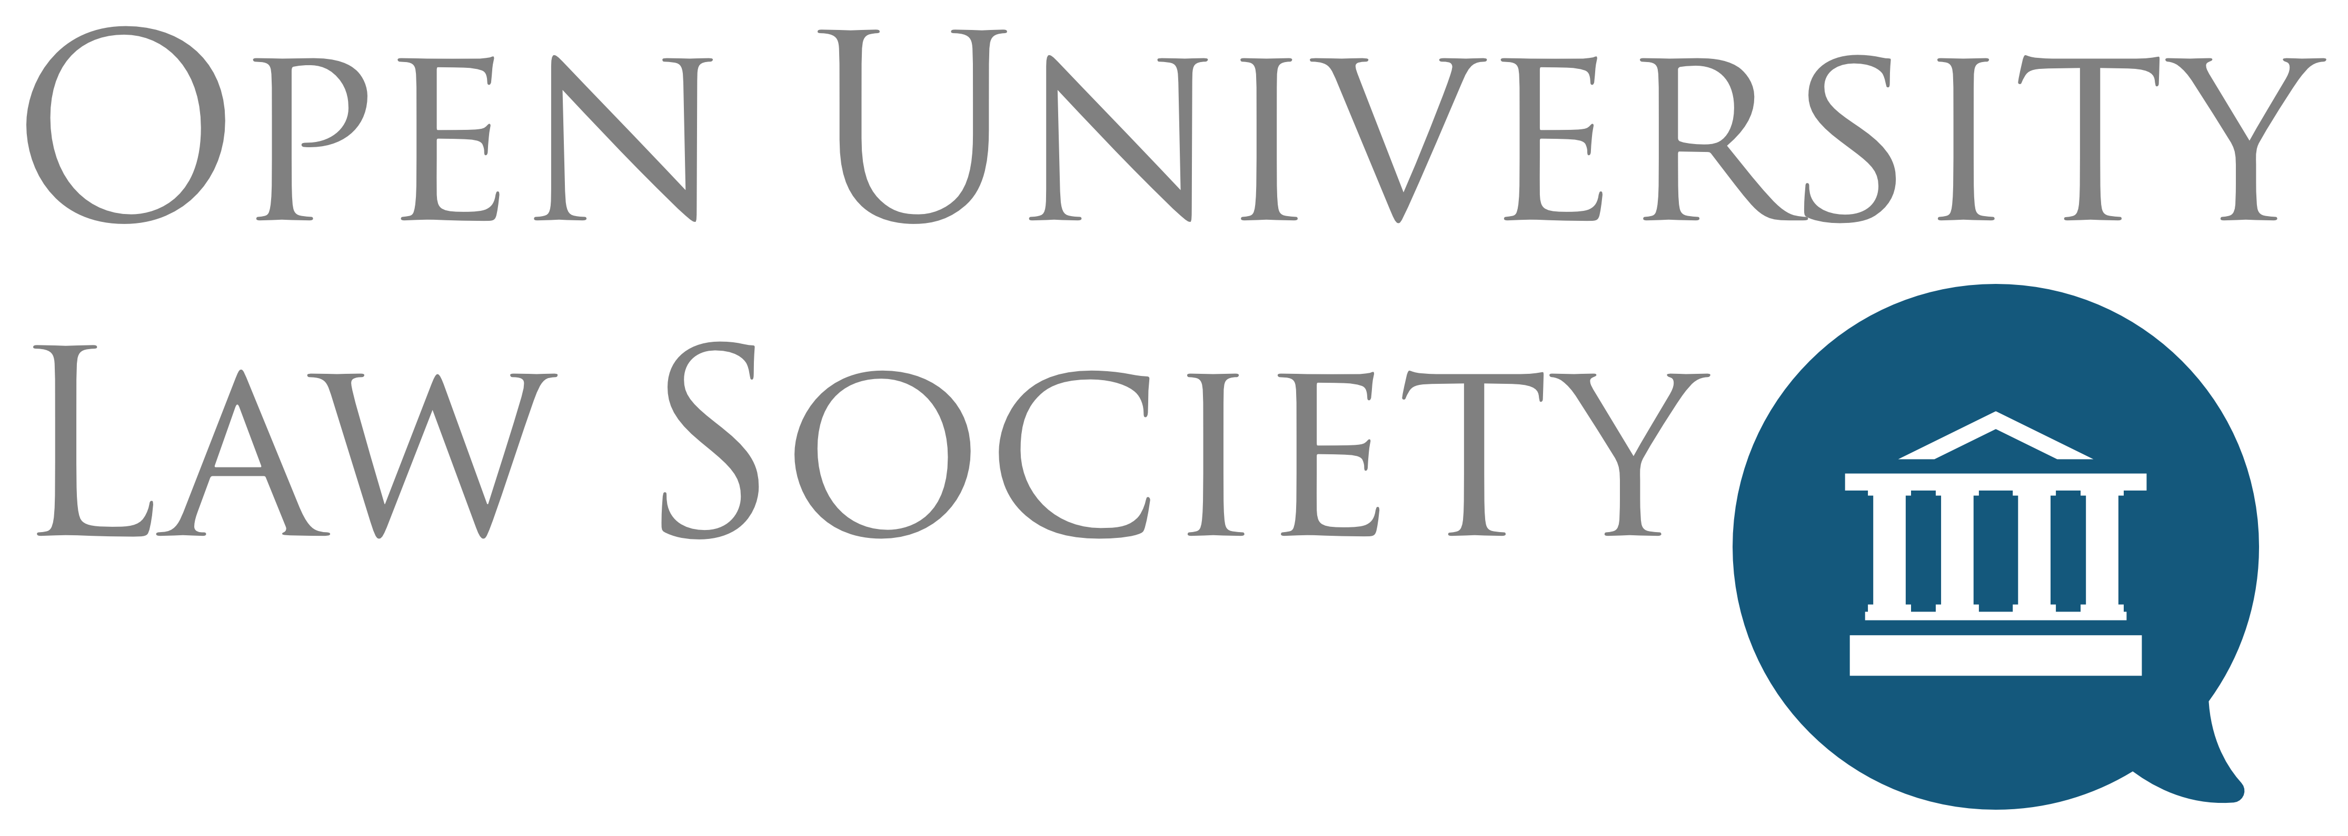

Would you like to host a street law workshop?
The Open University’s Open Justice Centre, in partnership with the OU Law Society, are offering Public Legal Education ‘Street Law’ workshops in secondary schools and community groups with the aim of promoting a greater understanding of law and legal issues. Through the interactive workshops, audiences engage on legal issues that are of particular relevance to them through a range of activities. The topics and length of the workshops can vary and would be tailored to the needs and interests of your school or organisation. These workshops can also help secondary schools to deliver the new SRE curriculum though using specialist legal knowledge to enhance the teaching on subjects required in the new curriculum.
In 2019 the workshops took place in 15 secondary schools across England and we are now looking to build on these. Popular topics for those workshops included:
- Cyber Bullying,
- Brexit,
- Human Rights,
- Social Media and the Law,
- Consent,
- Knife Crime, and
- Joint Enterprise.
The workshops are designed for pupils of secondary school ages, including sixth form pupils interested in a legal career or undergraduate law study. Audience sizes ranged from 20 to 100. The workshops were designed and delivered by OU law students.
Please do get in touch to find out how we can tailor the workshops to the needs of your pupils, curriculum or as part of preparation for further study. If you would like to discuss the possibility of hosting a workshop, please contact Kirst Lewington, street law co-ordinator via the OULS News Team newsteam@ouls.org.

More information on the Open Justice Centre is available on our website and blog.

