Meeting Minutes – Committee Meeting – 25/08/2022

Meeting Information
Objective: | Business as usual
Date: | Thursday 25 August 2022 | Time: | 19:00
Location: | Online - Zoom | Meeting Type: | Committee Meeting
Called By: | John Doran (Chair) | Facilitator: | John Doran (Chair)
Note Taker: | Joanne Clark | Submitted by: | Joanne Clark
Committee Members in Attendance:  Other Attendees: | John Doran (Chair), Isabelle Hoyet (Vice Chair), Joanne Clark (Secretary), Carla Turner (Mooting Coordinator), Zoë O’Connell (Editor)  -
Apologies: | None
Approved by: | Awaiting approval
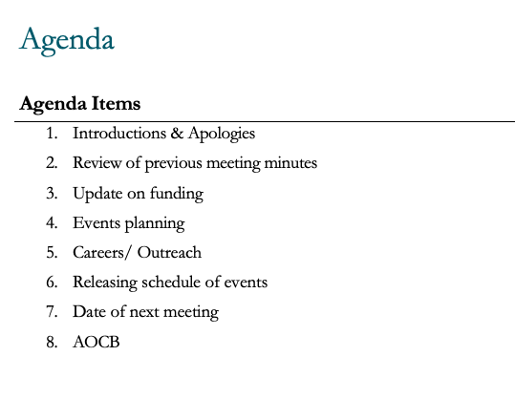

Minute
- Introduction and apologies. Gareth Jones (Treasurer) and Thomas Barry (Careers and Outreach Coordinator) absent.

- Discussion around accessibility about presentation of minutes. Agreed that font would be Arial 12. Typo in Isabelle’s name. Minutes accepted with those amendments.

- Funding update. Looking unlikely to secure funding from BPP, though accounts are looking healthy.

- Discussion around holding an essay competition. Previous years have not received many submissions, due to factors such as timing, workload of students and prizes offered. Agreement to revisit next year. Tour of Parliament event will be open to all, not just OULS members. Agreement not to restrict attendance at events to member only, except for Mooting events due to time & financial investment. It is difficult to police and may exclude some attendees due to membership being a paid for service.

- Moved to next meeting.

- Releasing schedule of events

- Date of next meeting – Monday 19 September 2022 at 7pm. Rearranged to Monday 26 September at 7pm due to the death of Queen Elizabeth II.

- AOCB

Meeting closed at 20:35pm.

Decisions:
Items for newsletter should be sent to Zoë by 25th of each month to be included.

Actions:
Action: | Assigned to: | Start date: | Due date: | Date completed:
Contact OUSA to advertise OULS events during Freshers Week | Isabelle Hoyet, Vice President | 5/08/2022 |  | 25/08/2022
Draft newsletter | Zoë O’Connell, Editor | 05/08/2022 |  | 25/08/2022
Advertise mooting events on social media | Carla Turner, Mooting Coordinator | 05/08/2022 |  | 25/08/22
Conduct a poll to finalise locations for in-person mooting events | Carla Turner, Mooting Coordinator | 05/08/2022 |  | 25/08/22
Obtain quotes for venues for mooting events | Carla Turner, Mooting Coordinator & John Doran, Chair | 05/08/2022 |  | 25/08/22
Begin planning for Xmas Parliament tour and social evening in London | John Doran, President | 05/08/2022 | In progress
Create request for volunteers to audit accounts to be shared on social media | Gareth Jones, Treasurer | 05/08/2022 | In progress
Recruit volunteers to assist with content creation | Zoë O’Connell, Editor | 05/08/2022 | Ongoing
Send template for funding applications to Vice Chair | John Doran, Chair | 05/08/2022 |  | 25/08/2022
Give Carla access to website | John Doran, Chair & Zoë O’Connell, Editor | 25/08/2022 |  | 01/09/2022
Procure banner for Fresher’s Fair and explore possible funding | Gareth Jones, Treasurer | 25/08/2022 | In progress
Send Zoom and Wix log in information and link to Isabelle & Carla | John Doran, Chair | 25/08/2022 | In progress
Update OULS info and calendar link on Study Home page and forum | John Doran, Chair | 25/08/2022 | In progress
Source room for London & Manchester Mooting workshops – discuss with Steph Williams | John Doran, Chair | 25/08/2022 | In progress
Hold lunch time social | Joanne Clark, Secretary | 04/11/2022 | Future dated

