**Newcastle Schools presentation – Some Support Materials**

**1 April 2019**

**Purpose:** I have prepared some additional information on the Articles that the group has selected for the presentation. These can be used to supplement the presentation as required. Alternatively, they can be used as part of any resource paper. I hope that they are helpful.

**Background:** Human Rights are concerned with the rights of an individual in relation to a Government.

* **Why did they attract attention?**

The European Convention on Human Rights and Fundamental Freedoms which was a treaty, was drawn up by the Council of Europe after WW2.

6 million Jews and millions of others including Romanis homosexuals and disabled die.

This policy of cruel treatment and deliberate, systematic genocide across German-occupied Europe shocked the world. The world united to agree on minimum standards of dignity to be afforded to all human beings. These minimum standards became known as human rights. They were recorded in the [Universal Declaration of Human Rights](https://rightsinfo.org/universal-declaration-human-rights/) and made enforceable in Europe under the [Human Rights Convention](https://rightsinfo.org/what-is-the-european-convention-on-human-rights-and-why-does-it-matter/).

* **When was it drafted?**

The [European Convention on Human Rights](https://www.theguardian.com/politics/2014/oct/03/kenneth-clarke-lambasts-conservatives-plan-quit-european-human-rights-convention) was drafted by the newly formed Council of Europe in Rome on 4 November 1950.

It came into force on 3 September 1953. The adoption of the convention by the Council of Europe was the first step in implementing the Declaration of Human Rights in writing.

It was developed to ensure that governments would never again be allowed to dehumanise and abuse people’s rights with impunity, and to help fulfil the promise of ‘never again’.

In May 1948 after the war had ended, the ‘Congress of Europe’ was held in The Hague, a gathering of over 750 delegates which included leaders from civil society groups, academia, business and religious groups, trade unions, and leading politicians from across Europe such as [Winston Churchill](https://en.wikipedia.org/wiki/Winston_Churchill), [François Mitterand](https://en.wikipedia.org/wiki/François_Mitterrand) and [Konrad Adenauer](https://en.wikipedia.org/wiki/Konrad_Adenauer).

In his speech to the Congress, Churchill stated: “In the centre of our movement stands the idea of a Charter of Human Rights, guarded by freedom and sustained by law.”

[Winston Churchill, (The Hague, 7th May 1948)](http://www.churchill-society-london.org.uk/WSCHague.html)

**Article 2: Everyone’s right to life shall be protected by law**

**Does the right to life under Article 2 include the right to death?**

Not according to current judicial interpretation ((Pretty v. United Kingdom (2002) 35 E.H.R.R 1, para. 39)):

Article 2 cannot, without a distortion of language, be interpreted as conferring the diametrically opposite right, namely a right to die, nor can it create a right to self-determination in the sense of conferring on an individual the entitlement to choose death rather than life.

Thus, euthanasia is a matter for national authorities and the law on assisted suicide varies throughout Europe. It remains an offence to assist someone’s suicide in the England under the Suicide Act 1961 – the provision that Mrs Pretty was seeking to challenge. She wanted to secure that while suicide is not now a criminal offence since 1967, it is still [an offence](http://www.legislation.gov.uk/ukpga/Eliz2/9-10/60/section/2) to help somebody to kill themselves.If her husband helped her, he was at risk of being prosecuted.

Diane Pretty asked the Director of Public Prosecutions – who has to agree to such cases being brought – to promise in advance that they wouldn’t prosecute her husband. They refused.She took the government to court, arguing the ban on assisting suicide was against her human rights.She was unsuccessful and also at the European Court.

The right to life in Article 2 doesn’t mean there’s a right to die. It is there to protect life itself, but it doesn’t have anything to do with the quality of life.

However, in the case of Daniel James, a young person paralysed in a rugby accident, the Director of Public Prosecutions recently accepted that there was ‘sufficient evidence’ to prosecute the parents who assisted his suicide in Switzerland but that it was ‘not in the public interest’ to do so.

'He wasn't prepared for a second-class life': why injured rugby star went to Switzerland to die” https://www.theguardian.com/uk/2008/oct/18/11

**What is the duty to investigate suspicious deaths?**

It must be effective – and, thereby, independent, prompt and transparent (Jordan and others v UK (2001)), ((Jordan and others v. United Kingdom (2003) 37 E.H.R.R. 2)) Deaths in England and Wales can be investigated by coroners through the medium of inquests for a number of reasons: about a third of all deaths are so treated.

**Article 4: No one shall be held in slavery or servitude**

Legislation has been produced to impose penalties for behaviour for human trafficking. **Human trafficking or modern slavery is one of the most appalling forms of criminal activity today. It’s also one of the most widespread and fastest-growing.**

The International Labour Organisation believes that at any one time at least [40.3 million](https://www.ilo.org/global/topics/forced-labour/lang--en/index.htm) people around the world are being coerced into a situation of exploitation or made to work against their will, often having been transported across borders. Such exploitation can take many different forms, but the most common include forced prostitution, forced labour or forced marriage.

UK nurse is first person convicted under modern slavery laws

Josephine Iyamu found guilty of trafficking five women from Nigeria to work as prostitutes

A British nurse has become the first person to be convicted under new modern [slavery](https://www.theguardian.com/world/slavery) laws, after being found guilty of trafficking five Nigerian women to Germany to work as prostitutes.

Josephine Iyamu was prosecuted under the Modern Slavery Act involving victims who have no connection to the UK but have been victimised by a British national.

Jurors were told the 51-year-old Liberia-born British citizen forced the women to swear oaths to hand over money to her during “juju” ceremonies. These included forcing women to eat chicken hearts, drink blood containing worms, and have powder rubbed into cuts, the court heard.

Iyamu, formerly of Bermondsey in London, then arranged for the women to be trafficked across the Mediterranean, with one being told to pay a “bill” of €37,000 (£32,700).

She was convicted at Birmingham Crown Court of five counts of arranging or facilitating travel for sexual exploitation.

**Article 8: Right to private life**

Rio Ferdinand: Sunday Mirror 'kiss and tell' was gross invasion of privacy

**Footballer tells high court judge how article put strain on his relationship with wife and caused him hurt and distress**

Rio Ferdinand, the Manchester United and England footballer, told a high court judge on Tuesday how a "kiss and tell" [Sunday Mirror](https://www.theguardian.com/media/sundaymirror) story put a strain on his relationship with his wife and caused him hurt and distress.

Ferdinand, who has three children with wife Rebecca, described an article published in the Sunday Mirror in April 2010 as "a gross invasion of my privacy".

Ferdinand told Mr Justice Nicol, who is hearing his claim for substantial damages, that he was "extremely upset to read the story, particularly because it came out of the blue".

In a witness statement before the court, the England player said the article, which is about an alleged affair with a woman called Carly Storey, caused "great distress not only to me but also to my wife and family".

He said: "It has been stressful and embarrassing for me to have to explain it to fellow professionals as well as family members and friends, and it has inevitably put a strain on my relationship with my wife.

"People also started shouting things out at me in the street after the article was published – things like, 'Where's your new bird?"'

Ferdinand said he had "not met this girl for six years" by the time the article was published. "It was stressful and very uncomfortable for me to have to do things like collect my kids from school, knowing that other parents there may have read the article and not realised that it was essentially a very old story."

He added: "Although I am a well-known person I make a clear distinction between my public and private life and do not seek publicity for my personal life.

"I do not see why I should not be entitled to a private life just because I am a famous footballer."

He told the court: "I accept that I have had a lot of benefits as a result of fame and fortune. I am not asking for any special treatment or to pretend that I am above criticism or a better person than anyone else. All I am asking for is the normal right to lead a private life which anyone has."

**Ferdinand v Mgn Ltd (Rev 2) [2011] EWHC 2454 (QB)**

he judge applied the standard “two part test”: first was the information in question in principle protected by Article 8?  Second, if so, the Court has to conduct a “balancing exercise” to decide which of Articles 8 and [10 (the right to freedom of expression)](http://ukhumanrightsblog.com/introduction/incorporated-rights/article-10/) should prevail [38] to [42]

The defendant argued that the information in the article was not subject to a “reasonable expectation of privacy” because in earlier times Mr Ferdinand and Ms Story had met in public places [45].  It was also argued that

*the Claimant is a public figure in a broad sense and, as such, he must accept and expect that his actions will be more closely scrutinised by the media …. [In addition] explicit details of the Claimant’s sex life were already in the public domain and the Claimant could no longer have a reasonable expectation of privacy in this type of information [47]*

These arguments were rejected by the Judge who held that, the information in the article was, in principle, protected by Article 8 [51].   He said that it was

*not necessary to consider whether, in an extreme case there would be some merit in the argument that widespread and extensive discussion by a person of similar aspects of their private life would disentitle them to have a reasonable expectation of privacy.  The present case comes nowhere near that extreme [58]*

The Judge, therefore, went on to consider the “balancing exercise”.  He noted that “one facet of the public interest can be correcting a false image, referring to the PCC Code and to Campbell v MGN [[2004] 2 AC 457](http://www.bailii.org/cgi-bin/redirect.cgi?path=/uk/cases/UKHL/2004/22.html) [65].

The Defendant argued that the Claimant had “projected an image of himself as a reformed character” and the published information showed that this was false [72].   The Claimant argued that no such “image” had been projected and that, in contrast to the Campbell case there was no “public lie” which required exposure.

The Judge held that there was a “public interest in this article” [84].  As a result of an interview given in the “News of the World” some years earlier the Claimant had

*projected an image of himself and, while that image persisted, there was a public interest in demonstrating (if it were to be the case) that the image is false  [85]*

A further factor in the case was the Claimant’s appointment as captain of the England football team [87].  The Judge said that appointment as England captain “carried with it an expectation of high standards” [89] and that there were “many who would … see the captain at least of the England football team as a role model” [90]

The Judge held that the article “reasonably contributed” to a debate as to whether the Claimant was suitable for role of England captain: “his relatively recent past failings could legitimately be used to called into question his suitability for the role” [98]

He concluded that, overall “the balancing exercise favours the Defendant’s right of freedom of expression over the Claimant’s right of privacy”. [105]

**Article 9: Freedom of thought conscience and religion**

R (on the application of Begum) v Denbigh High School Governors [2006] UKHL 1 A.C.

**A school which was told it unlawfully excluded a Muslim pupil for wearing a traditional gown has won its appeal at the House of Lords.**

The Court of Appeal had said Denbigh High School had denied Shabina Begum the right to manifest her religion in refusing to allow her to wear a jilbab.

But in a unanimous ruling, judges at the House of Lords overturned that.

They said the Luton school had "taken immense pains to devise a uniform policy which respected Muslim beliefs".

It had done so "in an inclusive, unthreatening and uncompetitive way".

**'Unwillingness to comply'**

They said: "The rules laid down were as far from being mindless as uniform rules could ever be."

They added: "It appeared the rules were acceptable to mainstream Muslim opinion."

Shabina Begum had chosen a school which "went to unusual lengths to inform parents of its uniform policy."

They ruled there was no interference with her right to manifest her religion as she had chosen a school where such a policy existed.

|  |  |
| --- | --- |
|  |  |

There were three other schools in the area which permitted the jilbab, they noted, although one was oversubscribed.

Miss Begum eventually attended another local school where she wore the jilbab.

Lord Bingham ruled that the two-year interruption of her schooling was the result of her "unwillingness to comply with a rule to which the school was entitled to adhere".

**'Make a stand'**

After the ruling, Miss Begum said: "Obviously I am saddened and disappointed about this, but I am quite glad it is all over and I can move on now.

"I had to make a stand about this. Many women will not speak up about what they actually want.

"I still don't see why I was told to go home from school when I was just practising my religion.

"I'm just a teenager - not many teenagers go out there and challenge the system."

She said the shalwar kameez (trousers and tunic) which Denbigh High School allows Muslim pupils to wear, "did not satisfy Islamic clothing".

"I feel it is an obligation upon Muslim women to wear this [the jilbab], although there are many other opinions."

She would consult her lawyers about a potential appeal to the European courts, she said.

In March last year, Denbigh High School said it had "lost on a technicality" when the Court of Appeal said it had failed to consider the Human Rights Act implications of its school uniform policy.

The school, where 79% of the pupils are Muslims, said it had reached its policy after consulting the Department for Education and Skills, leading Muslim groups, parents and pupils.

Lord Justice Brooke had called for more guidance for schools on complying with the Human Rights Act.

A DfES spokesman said he welcomed the ruling, which confirmed current school uniform policy was lawful.

"What an individual pupil should or should not wear in school is a matter for individual schools in consultation with parents."

**Article 10: Freedom of Expression**

79-year-old British bishop has failed in an attempt to challenge a German court conviction over remarks he made in a Swedish television programme. The European Court of Human Rights [ruled yesterday](http://hudoc.echr.coe.int/eng-press?i=003-6316456-8251051) that an application by Richard Williamson to overturn a conviction for incitement to hatred was inadmissible.

Williamson, a traditionalist Catholic and a former member of the breakaway fraternity Society of Saint Pius X, had been convicted by Regensburg District Court in 2012 for stating in a TV interview that he believed there were no gas chambers under the Nazi regime. He was fined €6,500, reduced to €1,800 on appeal.

Williamson was and is a UK resident and although the interview took place in Germany his comments were broadcast on Swedish television. The German court ruled that, in giving the interview, Williamson accepted that it might be viewed in Germany via the web and attract interest around the world.

On appeal to Strasbourg, Williamson argued that the conviction contravened Article 10 of the European Convention on Human Rights (freedom of expression) and that the offence was not committed in Germany’s jurisdiction. However a chamber of seven judges concluded that Williamson ’had sought to use his right to freedom of expression with the aim of promoting ideas contrary to the text and the spirit of the [ECHR].’

Ruling that the German authorities had not overstepped their margin of appreciation the court said that the interference with Williamson’s article 10 rights had been proportionate and ’necessary in a democratic society’. Williamson’s application was rejected as ’manifestly ill-founded’.

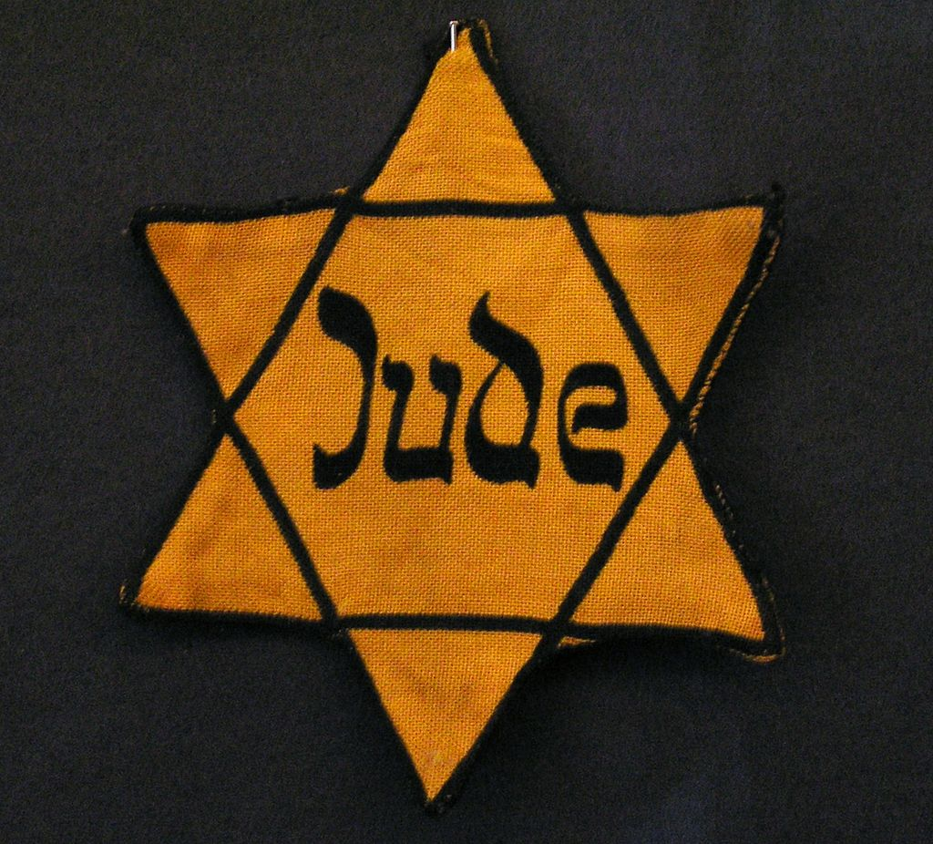

It starts with discrimination…



Free speech, marriage and family life

Books written by Jewish authors were [ordered](http://www.legal-tools.org/doc/a7608a/pdf/) to be removed from libraries and Jews were [banned](http://www.legal-tools.org/doc/45f18e/pdf/) from publishing German newspapers. Organisations [with potential influence](https://en.wikipedia.org/wiki/Gleichschaltung), including [trade unions](http://www.bbc.co.uk/schools/gcsebitesize/history/mwh/germany/hitlerconsolidaterev1.shtml), were eliminated. Today, the Human Rights Convention protects the freedoms of [expression](https://rightsinfo.org/your-rights-infographic/free-speech/), [assembly and association](https://rightsinfo.org/your-rights-infographic/protest-and-association/).

[German law](http://www.legal-tools.org/doc/a7608a/pdf/) under the Nazis specifically prohibited sexual intercourse and marriage between Jews and non-Jewish Germans. The Human Rights Convention specifically provides for a right to respect for [private and family life](https://rightsinfo.org/your-rights-infographic/family-and-privacy/) as well as the right to [marry](https://rightsinfo.org/your-rights-infographic/marriage/) in order to protect against such discriminatory laws.